EET-2235
Lab #4 Pressure

Purpose: The purpose of the lab is to introduce the student to a pressure transmitter and the calibration equipment needed to span and zero the transmitter. The student will interface a signal with a control device as well as generate a calibration curve for a transmitter.

Background: This lab introduces the student to pressure measurement techniques using a pressure transmitter and the calibration equipment required to set the zero (4mA) and span (20mA) of the transmitter. The equipment used is common to those used in industrial pressure measurement applications. A DAQ device (NI-ELVIS II+) will be used as the control device and a pressure transmitter will be used as the measuring instrument.

In order to create a variable pressure source, a portable digital manometer/calibrator will be used. The calibrator uses a small hand pump to generate a precise pressure signal and a digital readout device to indicate the pressure reading. A pressure transmitter, in turn, will be connected to the calibrator. (See Figure #3 below.)

Accuracy of an instrument is defined as the percent deviation of the span for an instrument: (Deviation/Span)x100%.

Linearity of an instrument is the maximum deviation of a calibration curve from a straight line. The straight line represents the ideal calibration (theoretical curve) and the calibration curve is the measured average curve traversed in both directions.
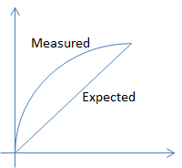
Figure #1 – Linearity of a Transmitter

Repeatability is the closeness of agreement between several consecutive measurements at the same output value taken in the same direction.

Hysteresis of an instrument is the difference between the maximum and minimum deviations of an upscale and downscale reading.

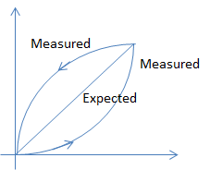
Figure #2 – Hysteresis of a Transmitter
Handheld
Calibrator
Pump
Pressure
Transmitter
P1
H

Figure #3 – Pressure Calibrator Hookup

Procedure:

- Connect the handheld pressure calibrator, pump, and pressure transmitter according to figure #3.

- Connect a 0-40 in.w.c. Dwyer pressure transmitter in a two wire configuration as shown in figure #4, using the (NI-ELVIS II+) 15VDC power supply, a 250Ω resistor, a DAQ Device (NI-ELVIS II+) and an ammeter. For a DAQ device, place a 250Ω resistor to the analog input channel 0 (AI0) and configure the DAQ Analog Input (AI0) to read a voltage signal on input channel 0. Use the LabVIEW program provided for Lab 3 to read the measured signal.

- Verify the transmitter calibration by setting the zero and span: 0”w.c.=4mA and 40”w.c.=20mA.

- Apply an upscale and downscale pressure to the transmitter input for 5 points from 0 in.w.c. - 40 in. w.c. and 40 in.w.c. – 0 in.w.c. Record the current and voltage reading for each point.

Pressure | Theoretical  Output (mA) | Measured Output  (Upscale)  (mA) (V) |  | Measured Output (Downscale)  (mA) (V)
0 | 4
10 | 8
20 | 12
30 | 16
40 | 20

- Set the input pressure to the upper range value (40”w.c.) so there is 20mA flowing in the circuit. Replace the 15 VDC power supply with the + Variable Power Supply(VPS) from the NI-ELVIS II. Start the VPS with the full 12 volts and slowing decrease the voltage until the 20mA current drops. Readjust the VPS so that the current just gets back to the 20mA. Measure the voltage across the Transmitter at this point. This is the minimum voltage for the transmitter. Using this value, calculate the maximum load that the transmitter can drive using a 15VDC and a 24VDC power supply.

Transmitter – Minimum Voltage
Maximum Load w/ 15VDC Power Supply
Maximum Load w/ 24VDC Power Supply

- Plot the data in EXCEL with Pressure on the horizontal axis and Current Reading on the vertical axis. (Do not need to graph Voltage)
  - How would you characterize the linearity of this instrument?

  - Calculate the accuracy of the instrument at 50% input using the largest deviation of the upscale and downscale current values. (Deviation/Span)x100%

- Replace the Dwyer transmitter with a Rosemount 3051 transmitter ranged 0-250 in.w.c. Verify the Rosemount transmitter calibration using the handheld calibrator.

- Apply an upscale and downscale pressure to the transmitter input for 5 points from 0 to 250 in.w.c. and from 250 in.w.c. to 0 in.w.c. Record the current and voltage reading for each point.

Pressure | Theoretical  Output (mA) | Measured Output  (Upscale)  (mA) (V) |  | Measured Output (Downscale)  (mA) (V)
0 | 4
62.5 | 8
125 | 12
187.5 | 16
250 | 20

- The Variable Power Supply does not provide enough power to operate this transmitter so use the minimum voltage found for this instrument in Lab #2 and determine the maximum load that the transmitter can drive given a 15VDC and a 24VDC power supply.

Transmitter – Minimum Voltage
Maximum Load w/ 15VDC Power Supply
Maximum Load w/ 24VDC Power Supply

- Plot the data in EXCEL with Pressure on the horizontal axis and Current Reading on the vertical axis. (Do not need to graph Voltage.)
  - How would you characterize the linearity of this instrument?

  - Calculate the accuracy of the instrument at 50% input using the largest deviation of the upscale and downscale current values. (Deviation/Span)x100%

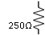
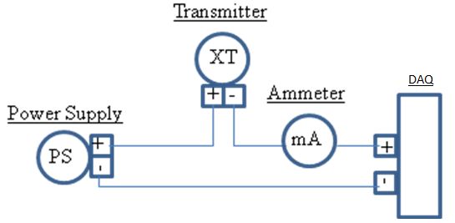
Figure #4 – Transmitter Wiring Diagram

